

**CSE370**

**Database Systems**

**Spring-24**

**Lab Assignment - 2**

**Name: Faiaz Abrar Zaman Pronoy**

**Student ID: 22301061**

**Section: 13**

**DATABASE + TABLE CREATE**

CREATE DATABASE 22301061_FAIAZ_PRONOY_LAB_02;

SHOW DATABASES;

USE 22301061_FAIAZ_PRONOY_LAB_02;

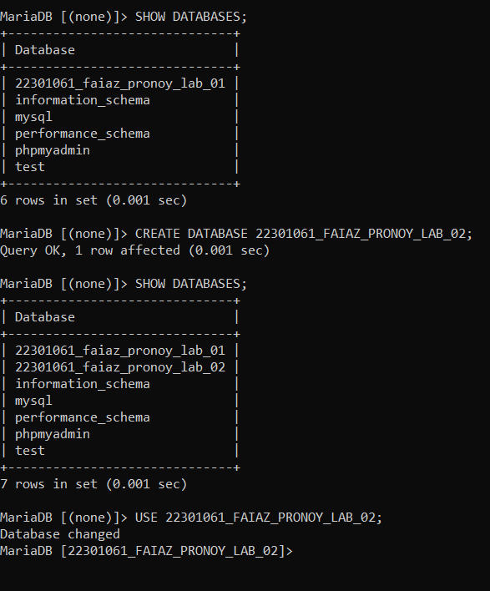

CREATE TABLE Employee (

employee_id CHAR(10),

first_name VARCHAR(20),

last_name VARCHAR(20),

email VARCHAR(60),

phone_number CHAR(14),

hire_date DATE,

job_id CHAR(10),

salary INT,

commission_pct DECIMAL(5,3),

manager_id CHAR(10),

department_id CHAR(10) );

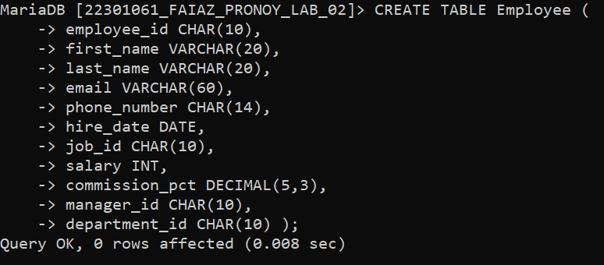

DESCRIBE Employee;

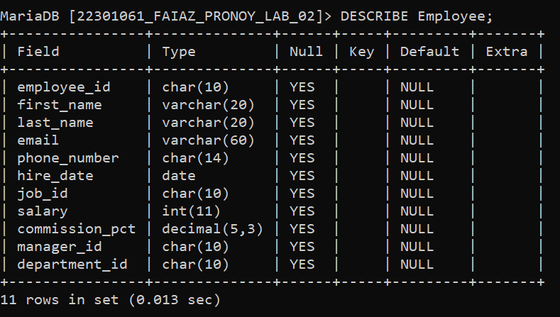

INSERT INTO Employee VALUES

('EMP001', 'Faiaz', 'Pronoy', 'fazpronoy@gmail.com', '+8801620044333', '2021-01-21', 'JOB001', 90000, 15.63, 'MNG001', 'DPT001'),

('EMP002', 'Sinthia', 'Khandoker', 'sinthiakhandoker@gmail.com', '+8801620044366', '2013-10-29', 'JOB002', 10000, 10.52, 'MNG001', 'DPT003'),

('EMP003', 'Jahirul', 'Zishan', 'jahirulzishan@yahoo.com', '+8801620044360', '2022-10-03', 'JOB003', 50000, 8.02, 'MNG002', 'DPT007'),

('EMP004', 'Niamul', 'Hasan', 'niamulhasan@gmail.com', '+8801620044390', '2017-05-14', 'JOB003', 28000, 12.67, 'MNG002', 'DPT005'),

('EMP005', 'Talha', 'Islam', 'talhaislam@gmail.com', '+8801620044345', '2015-07-05', 'JOB001', 25000, 18.12, 'MNG001', 'DPT005'),

('EMP006', 'Dokhan', 'Kamal', 'dokhankamal@gmail.com', '+8801620044125', '2011-11-04', 'JOB006', 72000, 6.07, 'MNG003', 'DPT007'),

('EMP007', 'Ishrak', 'Hamim', 'ishrak@gmail.com', '+8801620044355', '2023-10-07', 'JOB002', 16000, 13.55, 'MNG003', 'DPT007'),

('EMP008', 'Siam', 'Ferdous', 'siam@yahoo.com', '+8801620044377', '2023-10-18', 'JOB003', 79000, 9.1, 'MNG002', 'DPT007'),

('EMP009', 'Uday', 'Khan', 'uday@yahoo.com', '+8801620044399', '2022-06-09', 'JOB004', 60000, 7, 'MNG002', 'DPT003'),

('EMP010', 'Sirajum', 'Munira', 'munira@yahoo.com', '+8801620044344', '2018-06-06', 'JOB004', 44000, 11.543, 'MNG001', 'DPT002'),

('EMPO11', 'Zaynul', 'Abedin', 'abed@gmail.com', '+8801620044345', '2020-07-11', 'JOB001', 3000, 16.06, 'MNG003', 'DPT005'),

('EMPO12', 'Nowshin', 'Sumaiya', 'nowshinsumaiya@outlook.com', '+8801620044321', '2023-04-02', 'JOB001', 78300, 19.147, 'MNG002', 'DPT002');

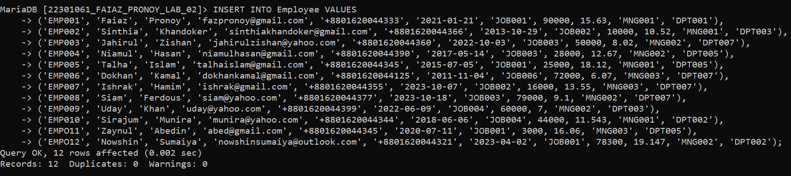

SELECT * FROM Employee;

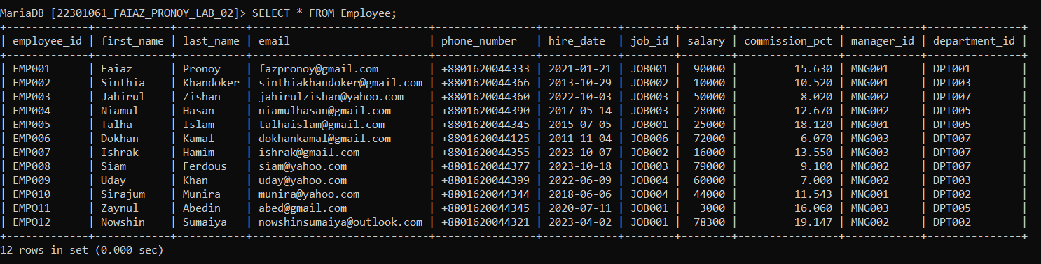

**TASK_01**

SELECT first_name, last_name, email, phone_number, hire_date, department_id FROM Employee

WHERE hire_date = (SELECT MAX(hire_date) FROM Employee);

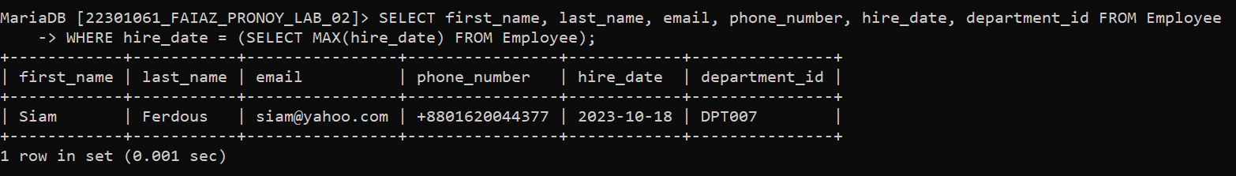

**TASK_02**

SELECT first_name, last_name, employee_id, phone_number, salary, department_id FROM Employee e1

WHERE salary = (SELECT MIN(salary) FROM Employee e2 WHERE e1.department_id = e2.department_id) GROUP BY department_id;

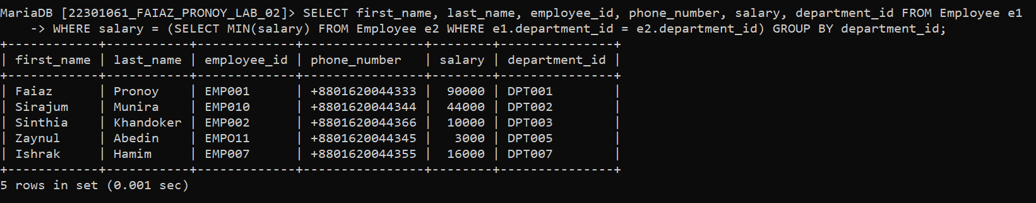

**TASK_03**

SELECT first_name, last_name, employee_id, commission_pct, department_id FROM Employee

WHERE department_id = 'DPT007' AND commission_pct < ALL(SELECT MIN(commission_pct) FROM Employee WHERE department_id = 'DPT005');

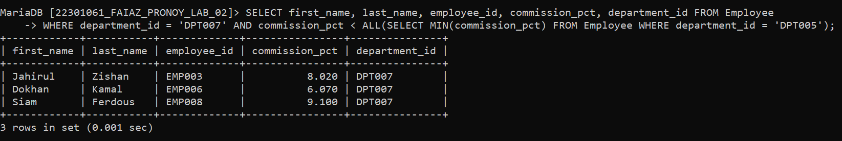

**TASK_04**

SELECT department_id, salary, count(*) AS total_employees FROM Employee GROUP BY department_id

HAVING salary <= 30000;

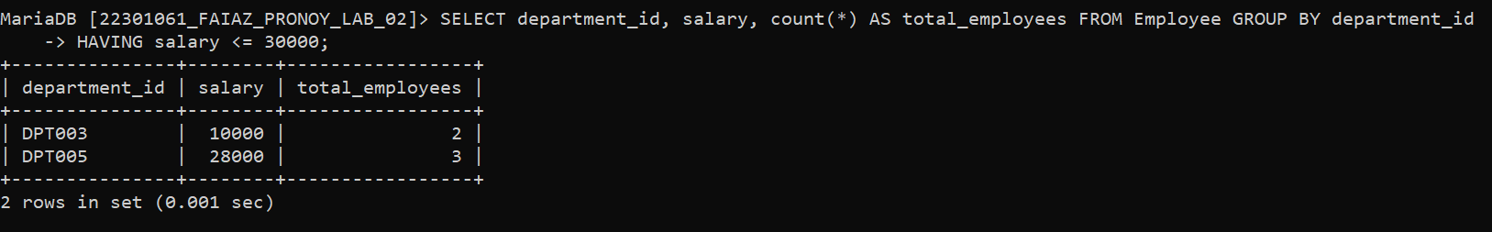

**TASK_05**

SELECT department_id, job_id, commission_pct FROM Employee e1

WHERE commission_pct < ANY(SELECT commission_pct FROM Employee e2

WHERE e1.department_id = e2.department_id AND e1.job_id != e2.job_id);

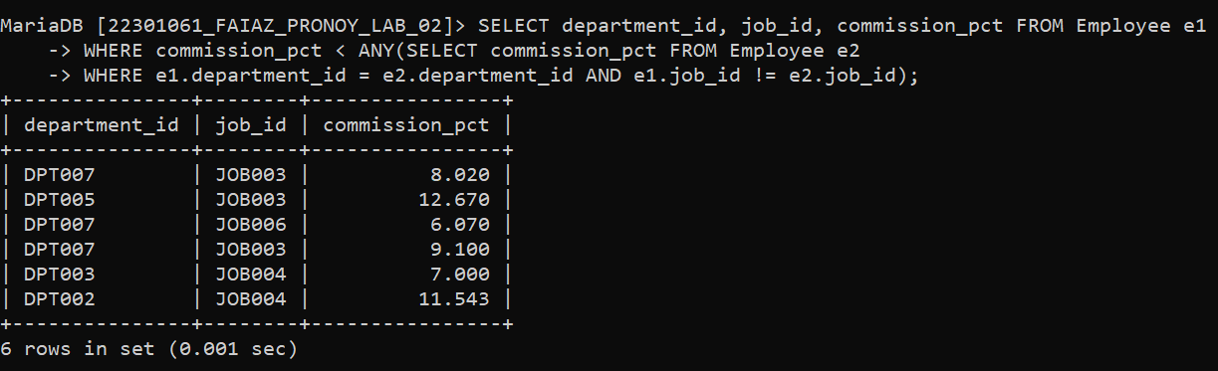

**TASK_06**

SELECT manager_id FROM Employee GROUP BY manager_id HAVING MIN(salary) >= 3500;

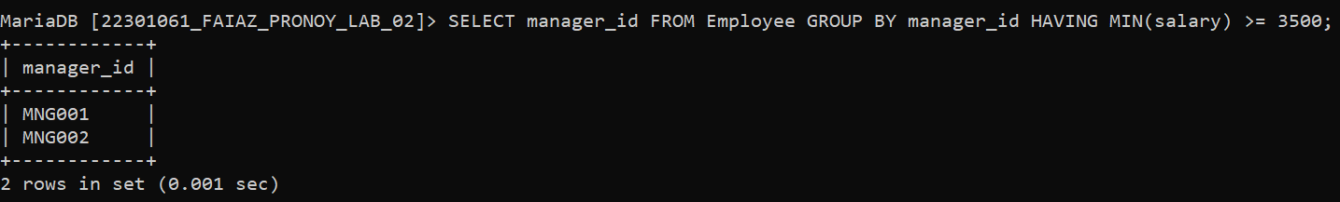

**TASK_07**

SELECT first_name, last_name, employee_id, email, salary, department_id, commission_pct FROM Employee e1

WHERE commission_pct = (SELECT MIN(commission_pct) FROM Employee e2

WHERE e1.manager_id = e2.manager_id);

